Syeda Reeha Quasar

14114802719

4C7

Aim

To perform the environmental view diagram: Deployment diagram for the system.

Experiment - 9

Software Engineering Lab

# **EXPERIMENT – 9**

## **Aim:**

To perform the environmental view diagram: Deployment diagram for the system.

## **Theory:**

## The deployment diagram shows how a system will be physically deployed in the hardware environment. Its purpose is to show where the different components of the system will physically run and how they will communicate with each other. Since the diagram models the physical runtime, a system's production staff will make considerable use of this diagram.

## The notation in a deployment diagram includes the notation elements used in a component diagram, with a couple of additions, including the concept of a node. A node represents either a physical machine or a virtual machine node (e.g., a mainframe node). To model a node, simply draw a three-dimensional cube with the name of the node at the top of the cube.

## **Performance Instruction:**

**To create a deployment diagram**

* Identify component
* Add shapes
* Connect Nodes
* Format arrows

## **Output:**

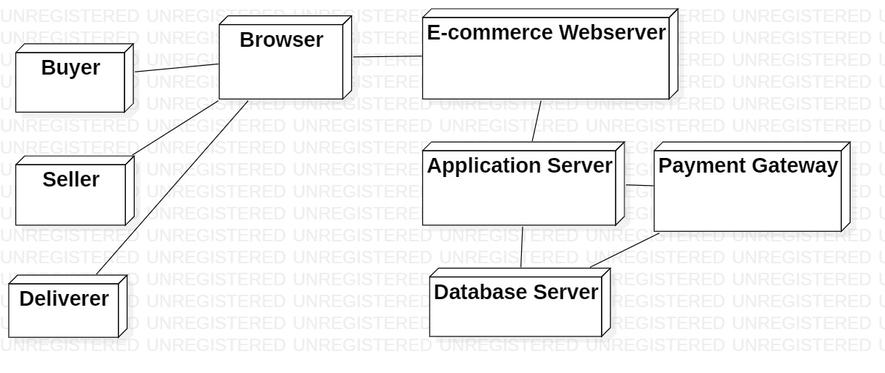

**Conclusion:**

Deployment diagram was made successfully by following above steps.

# **Viva Questions**

### **1. What is deployment diagram?**

### Ans.

Deployment diagrams are used to visualize the topology of the physical components of a system, where the software components are deployed. Deployment diagrams are used to describe the static deployment view of a system. Deployment diagrams consist of nodes and their relationships.

### **2. Deployment diagram explains which view of system?**

### Ans.

Deployment diagrams are used to describe the static deployment view of a system.

### **3. Explain steps to draw deployment diagram?**

### Ans.

### To create a deployment diagram

### Identify component

### Add shapes

### Connect Nodes

### Format arrows

### **4. Explain symbols used to draw deployment diagram?**

### Ans.

**Communication path:** A straight line that represents communication between two device nodes.

**Artifacts:** A box with the header ">" and then the name of the file.

**Package:** A file-shaped box that groups together all the device nodes to encapsulate the entire deployment.

**Nodes**

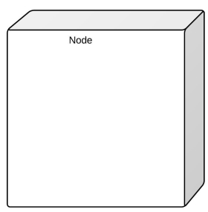

There are two types of nodes in a deployment diagram: device nodes and execution environment nodes. Device nodes are computing resources with processing capabilities and the ability to execute programs. Some examples of device nodes include PCs, laptops, and mobile phones.

### **5. What is benefit of drawing deployment diagram?**

### Ans.

System engineers mainly consume deployment diagrams. These diagrams help us to describe the physical components like hardware involved, participant nodes, their distribution and how they are inter-connected Deployment diagrams could be assumed as the hardware components where the software components reside.